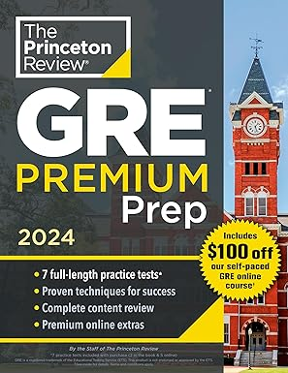 ₦35,500

Princeton Review GRE Premium Prep, 2024: 7 Practice Tests + Review & Techniques + Online Tools (Graduate School Test Preparation) (The Princeton Review Gre Premium Prep)

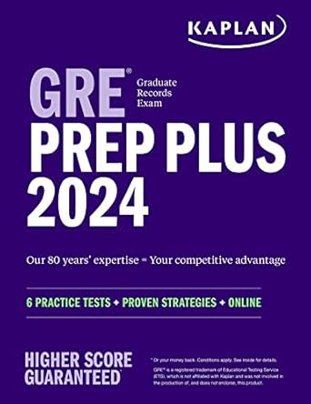 ₦55,000

GRE Prep Plus 2024: 6 Practice Tests + Proven Strategies + Online (Kaplan Test Prep)

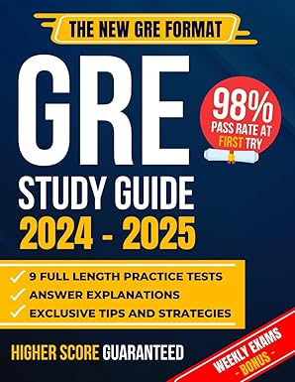 ₦55,900

GRE Study Guide: The Most Complete Guide to Passing the Exam on Your First Try with the Highest Score | Includes 9 Full Exam Simulations and EXTRA Weekly Exams Based on the New GRE Format

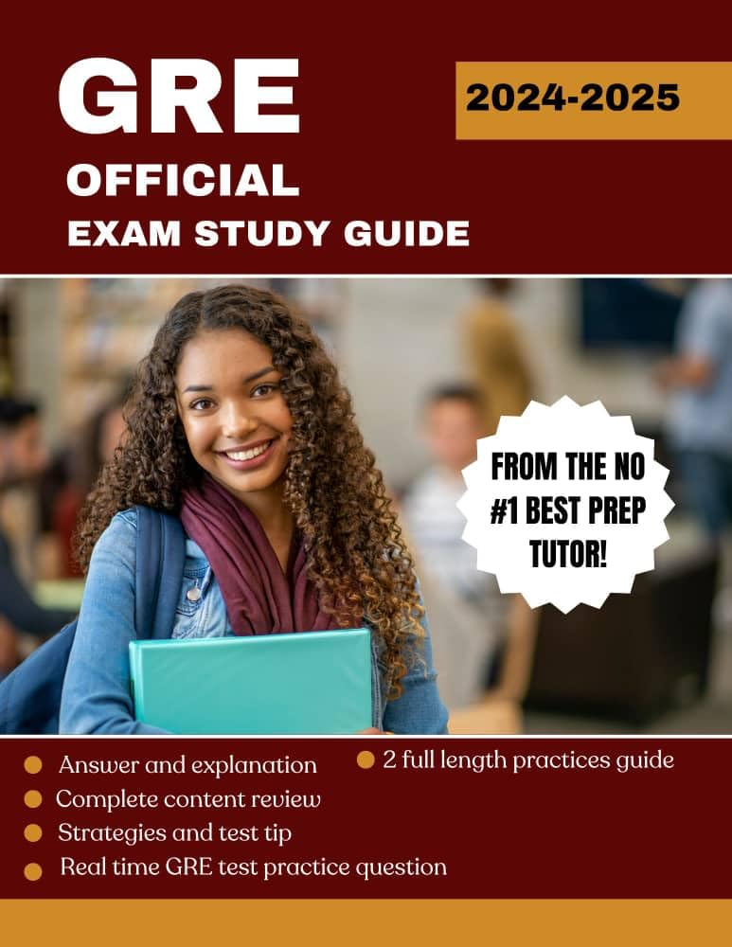 ₦49,500

GRE OFFICIAL EXAM STUDY GUIDE: Mastering the GRE exam, featuring expert strategic,in depth practice test and proven tips for optimal performance in subject

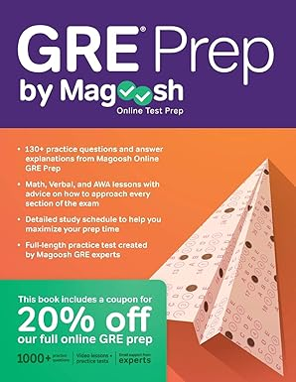 ₦45,500

GRE Prep by Magoosh

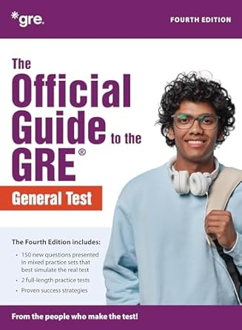 ₦98,700

The Official Guide to the GRE Test, Fourth Edition 4th Edition

